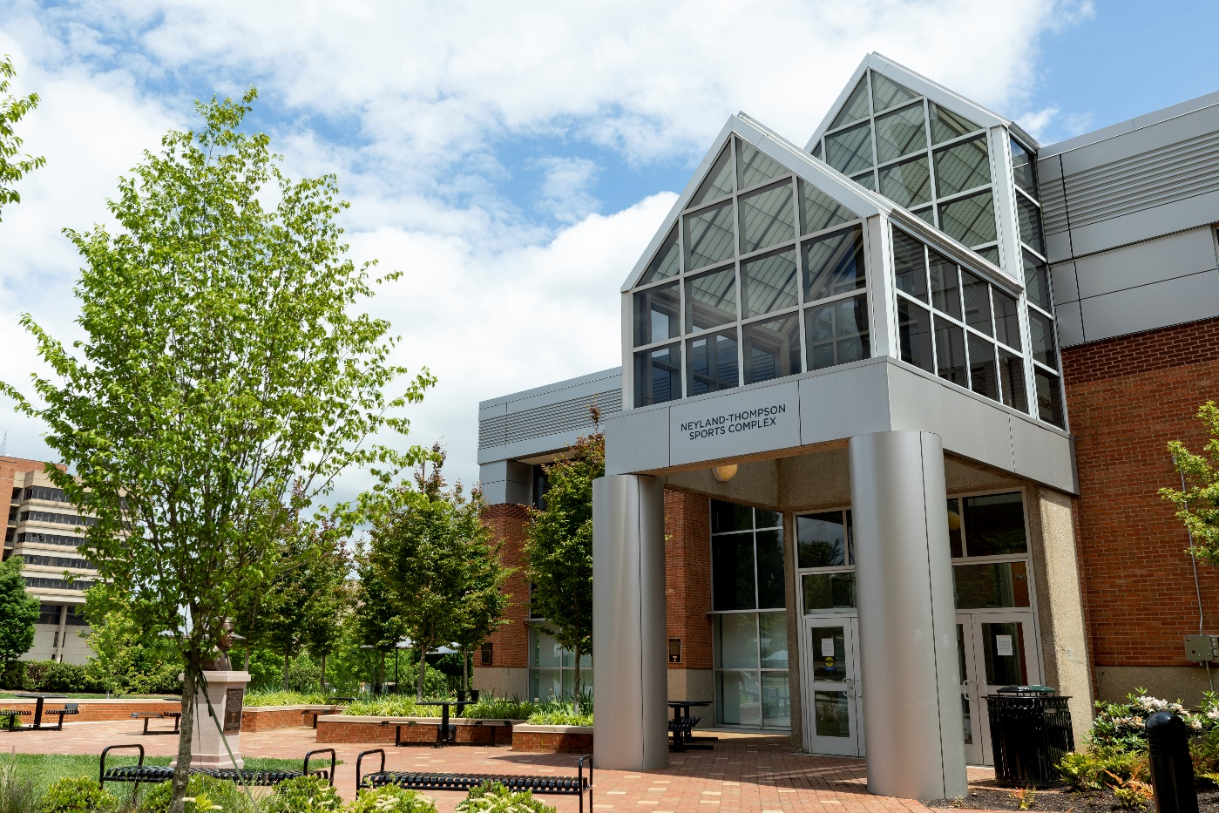
Neyland-Thompson Sports Center
The Neyland-Thompson Sports Center houses Tennessee's indoor football field and several administrative and team offices.

The Neyland-Thompson Sports Center provides Tennessee athletes with the finest strength and conditioning, dressing, health care, meeting and coaching facilities in the country.

The facility houses the Carmichael Strength Facility as well as the Tim Kerin Athletic Training Room.

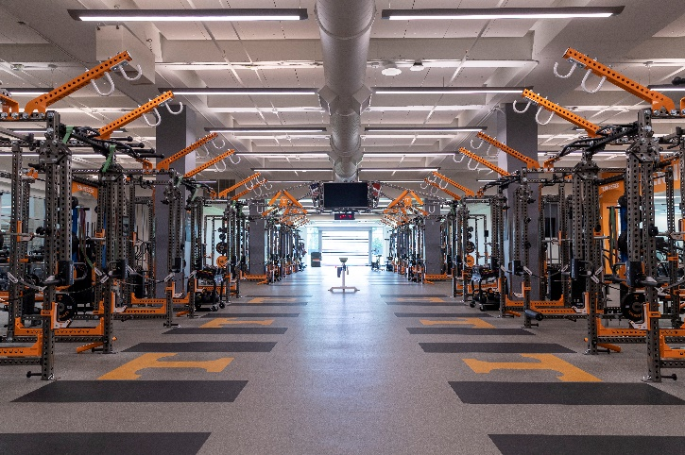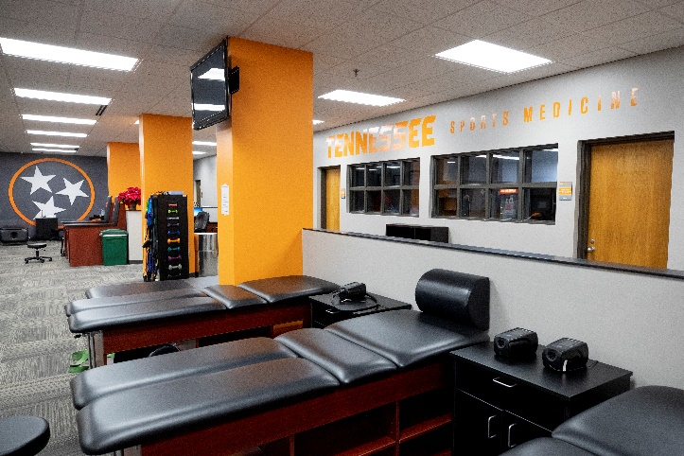

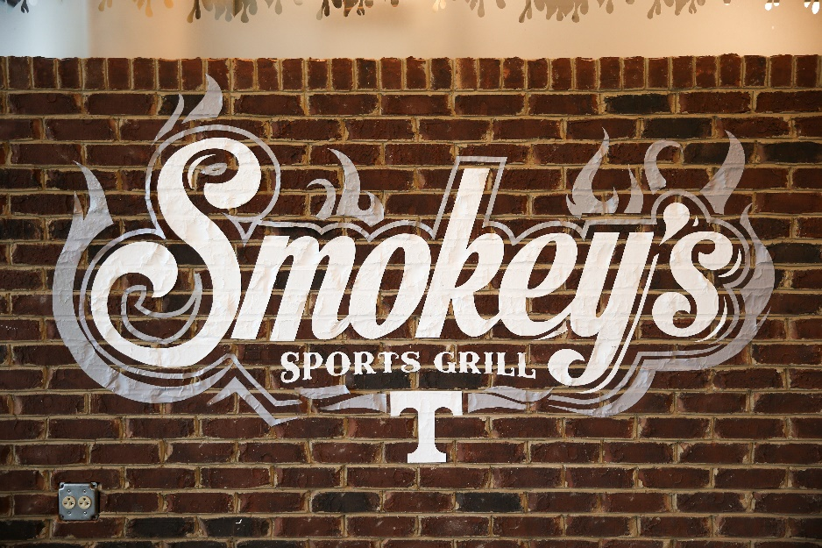
Smokey’s Sports Grill
Smokey's Sports Grill, located just steps away from the south end of the Robert E. White Indoor Field and directly beneath the Adair-Carlson Student-Athlete Wellness Center, is part training table and part sports-themed restaurant, functional to meet the nutritional needs of Tennessee student-athletes while also comfortable enough to be a place for teams to bond.

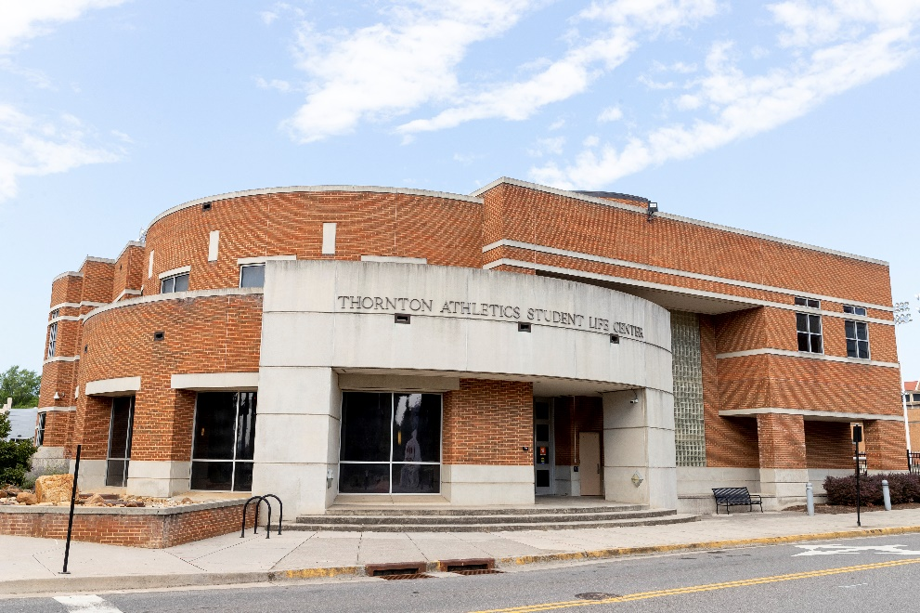
Thornton Athletics Student Life Center
The Thornton Athletics Student Life Center is a state-of-the-art, 33,000 sq/ft facility that houses the Tennessee Tailored program, which encompasses academic counseling and career development services for student-athletes.

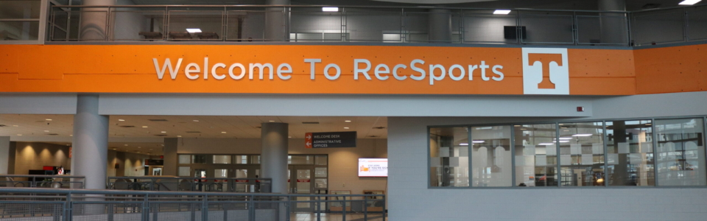
TRECS
RecSports is the Department of Recreational Sports within the Division of Student Life at the University of Tennessee. It serves students, faculty, and staff by providing a wide variety of programs and well-maintained facilities for almost any sport- or fitness-oriented person. We utilize this space as an on-campus location for our ballet and technique training.

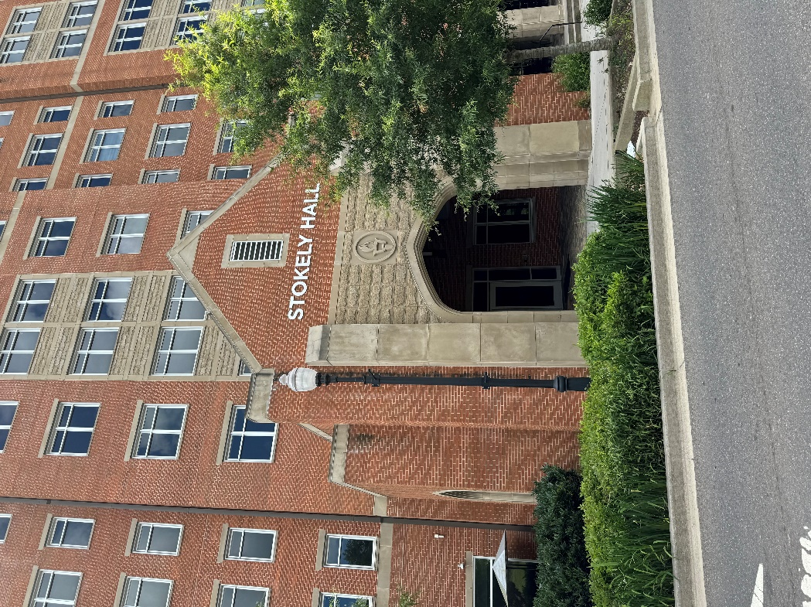
Stokely Hall
Stokely Hall provides housing to 670 students. Super-suite style residence halls feature private or shared bedrooms, with a shared living area. Stokely Hall is adjacent to a 1,020-space parking garage and in close proximity to the Natalie Haslam Music Center, Art & Architecture Building, Neyland-Thompson Sports Center and Student Health Center.

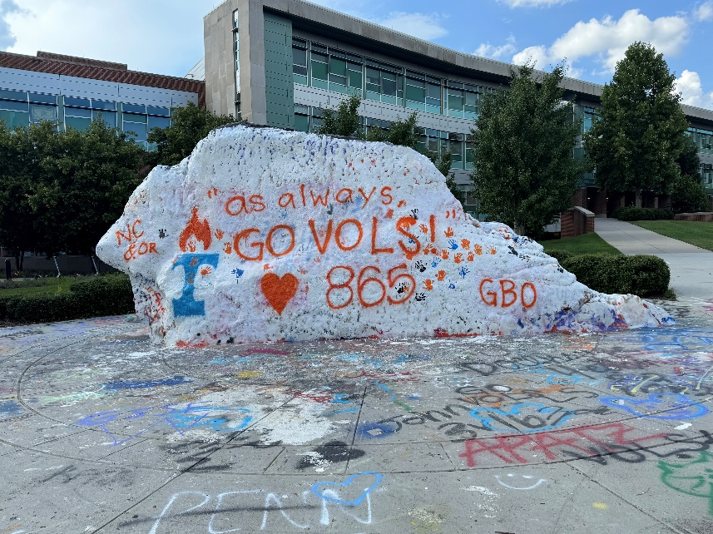
The Rock
An iconic UT landmark for more than 50 years, the Rock is a place of free expression on campus, a public canvas where thousands of artists have expressed themselves. Unearthed in 1966, the Rock has been a fixture of campus life ever since, and painting the Rock has become a treasured campus tradition.

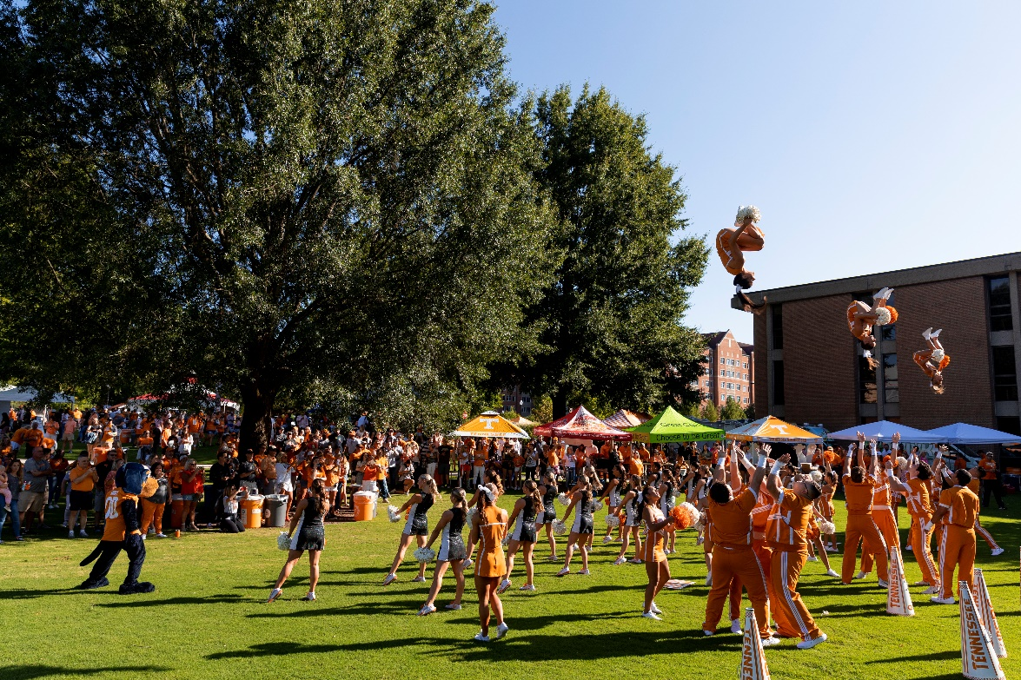
Vol Village
Make sure you visit Vol Village presented by Toyota before football games this year for a whole new fan experience. It’s FREE for all fans with or without a game ticket. There will be live music, activities for everyone of all ages, food trucks, and more. You won’t want to miss out on stopping by a reimagined, Vol Village, located in a great spot to see the Vol Walk and the Band March just across from Circle Park.

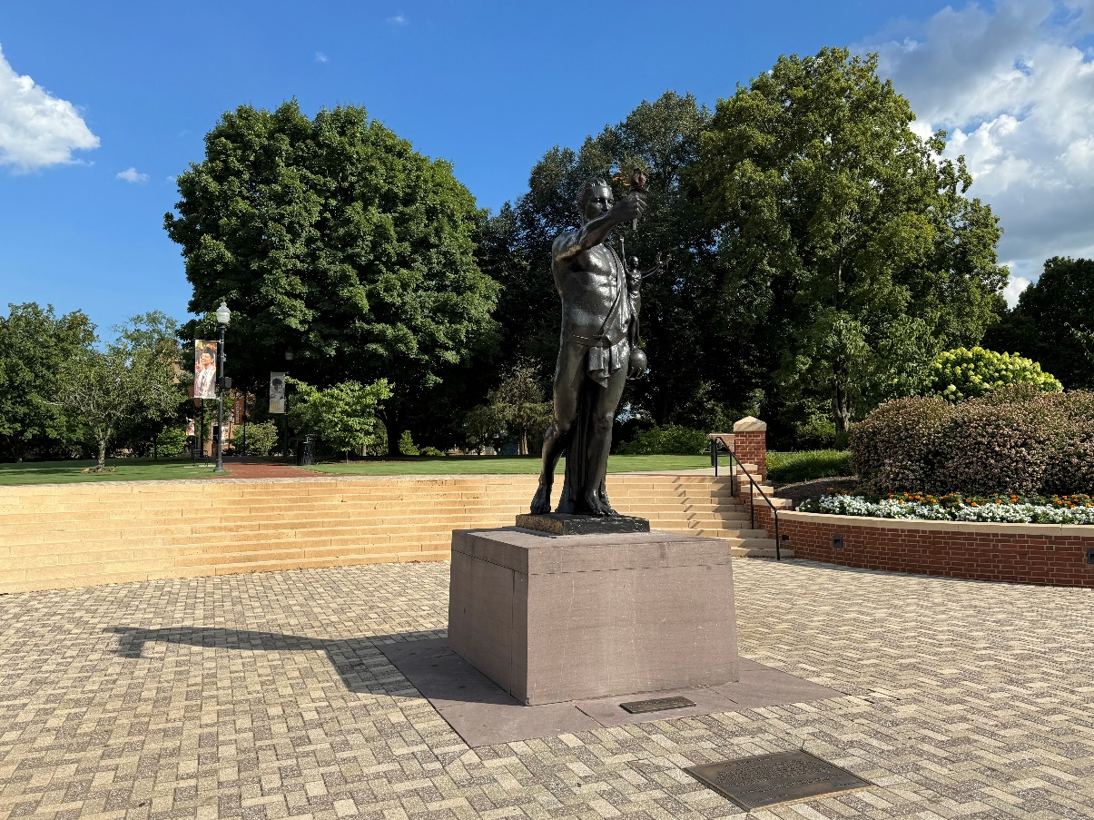
Torchbearer
The iconic Torchbearer statue is a symbol of enlightenment, leadership, and service.

Around the country, Volunteers are known for their willingness to put others before themselves. It is that ideal—a commitment among past, present, and future Vols to lead wherever they are—that is embodied in one of the most visited sites on the University of Tennessee, Knoxville’s campus.

Standing on the edge of Circle Park, the Torchbearer statue proudly displays the Volunteer Creed: One that beareth a torch shadoweth oneself to give light to others.
Its torch, which bears a flame that never extinguishes, is a symbol of knowledge and enlightenment—a belief that truth and reason overcome ignorance.

Parent Tailgate
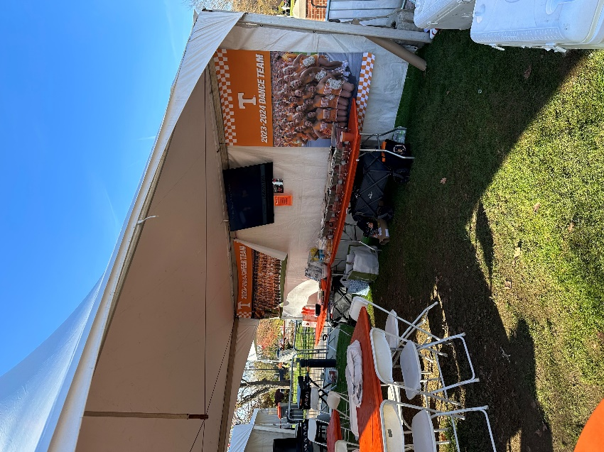
On Game Day Saturdays in the fall you can find the spirit team tailgate, just past the Iconic Torchbearer statue in Circle Park. Mix and mingle with parents from the Cheer, Dance, and Mascot teams.

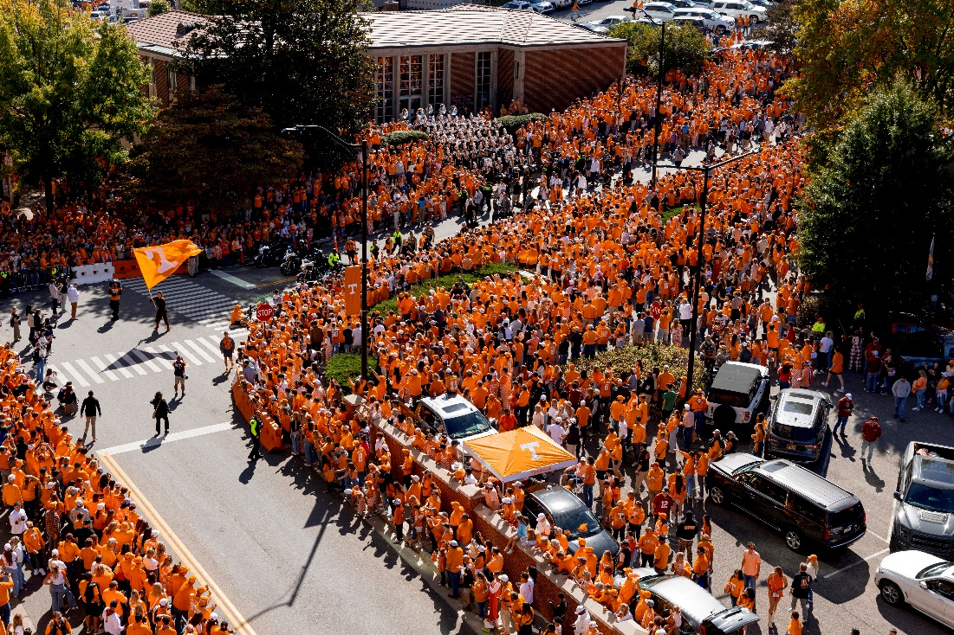
Vol Walk
The Vol Walk -- the football team's walk to Neyland Stadium -- begins 2 hours and 15 minutes before kickoff at the Torchbearer statue in Circle Park on Volunteer Drive. It continues down Peyton Manning Pass before turning left on Phillip Fulmer Way and into the stadium through Gate 21-A.

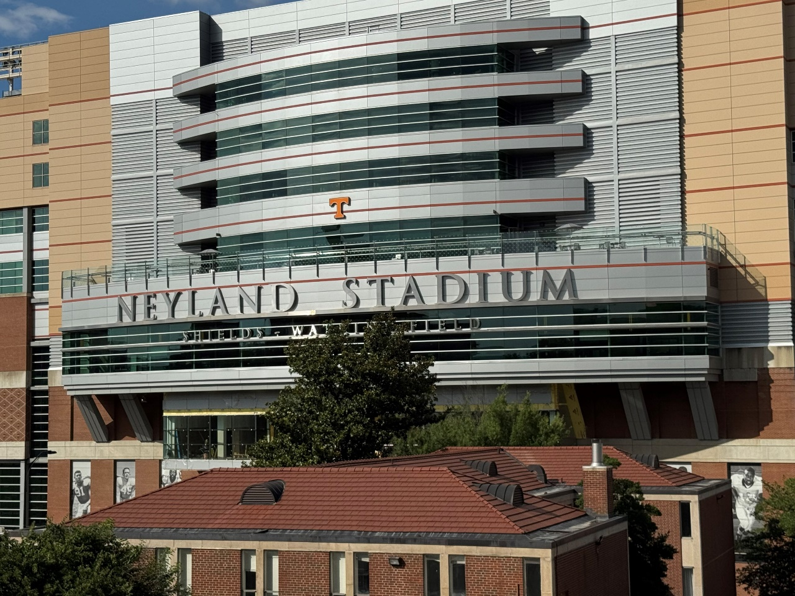

Neyland Stadium
Preserved by Pilot
One of the most iconic landmarks in sport, Neyland Stadium is the sixth-largest college football venue in the nation.

Tennessee Athletics in the fall of 2021 celebrated 100 years of Volunteers football at historic Neyland Stadium, ushering in a new era. During its first century of service to the Big Orange faithful, the venue grew in both capacity and reverence while evolving into one of the most iconic sporting venues in the world. This legacy lives on thanks to a transformative partnership with Pilot.

Six Tennessee teams that captured national championships have called Neyland Stadium home, while 22 players and four head coaches authored careers worthy of the National Football Foundation and College Hall of Fame on Neyland’s hallowed ground.

The present day Neyland Stadium, Shields-Watkins Field, had its beginning in 1919. Col. W.S. Shields, president of Knoxville's City National Bank and a UT trustee, provided the initial capital to prepare and equip an athletic field. Thus, when the field was completed in March 1921, it was called Shields-Watkins Field in honor of the donor and his wife, Alice Watkins-Shields.

The stadium, apart from the field it grew to enclose, came to bear its own distinguished name—Neyland Stadium. It was named for the man most responsible for the growth and development of Tennessee's proud football tradition. General Robert R. Neyland served as head coach from 1926-1952, with two interruptions for military service.

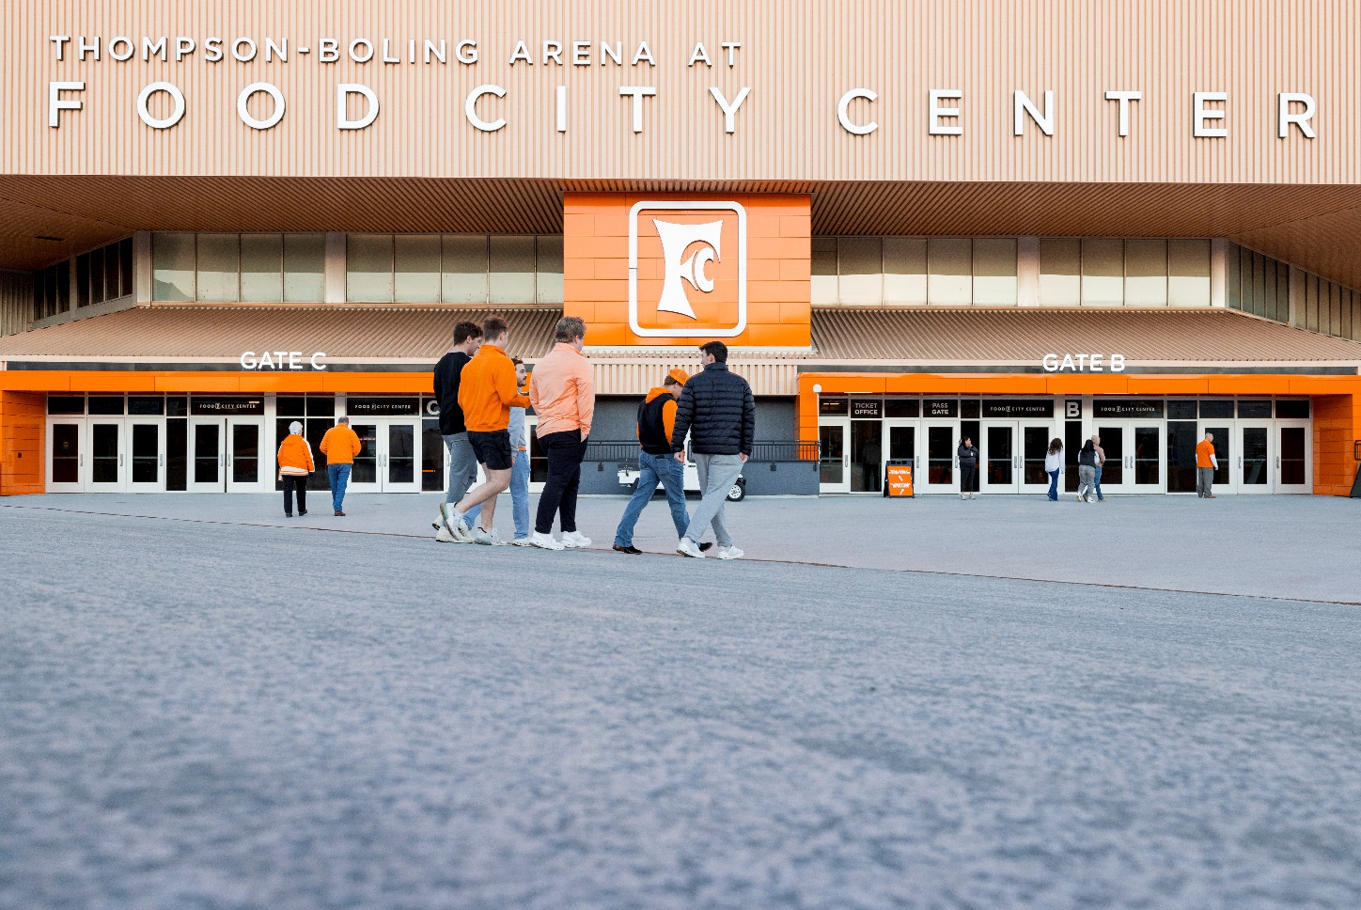

Thompson-Boling Arena at Food City Center
The third-largest on-campus basketball arena in the country, Thompson-Boling Arena at Food City Center is one of the nation's biggest and brightest stages for college basketball.

Thompson-Boling Arena opened during the 1987-88 season, with the Tennessee men's basketball team defeating Marquette 82-56 before a crowd of 25,272 on Dec. 3. The Lady Vols raced to a 102-59 victory over Stetson earlier that evening.

In the venue's opening season, the Volunteers finished third nationally with an average attendance of more than 20,000 fans per game.

